Vehicle Rental

[Company name] | [Company address]

A3 Documentation

Jacob Cerff

2017

Contents

Introduction: 2

Requirements: 2

Prototype Tool Used: 2

UI Design: 2

Test Table: 2

Unit Testing: 2

GitHub Link: 3

Knowledge Evidence: 3

# Introduction:

Vehicle Rental

This assessments application is to create a Vehicle Rental program (details of requirements below). The application is written in C# language and the overall scope of the program is split into four separate parts.

* The start, or phase one is to get the first requirement and the starting design of the program created
* Phase two, start creating a final design of the program and adding code to complete all the requirements of the assessments
* Phase three is testing the application created, fix all errors found
* Phase four knowledge questions to be completed

# Requirements:

The following requirements were detailed for phase 1:

* The application must have one of each of the following classes:
  + Vehicle
  + Journey
  + Fuelpurchased
* An output similar to this:
  + Manufacturer: Ford
  + Model: T812
  + Make Year: 2014
  + Registration No: 1 ABD 760
  + Total Kilometres Travelled: 294.0
  + Total Services: 2
  + Fuel Economy: 10L/100km
  + Requires a Service: No

The following requirements were detailed for phase 2:

* The application must have one of each of the following classes:
  + Vehicle
  + PerKMRental
  + PerDayRental
  + Service
* An output similar to this:
  + Manufacturer: Audi
  + Model: A6
  + Make Year: 2003
  + Registration No: 1 ABC 221
  + Total Kilometres Travelled: 0
  + Total services: 0
  + Revenue recorded: $0
  + Kilometres since the last service: 0
  + Fuel economy: 0
  + Requires a service: No

# Prototype Tool Used:

Visual studio 2015

# UI Design:

Screenshots found below of the final UI

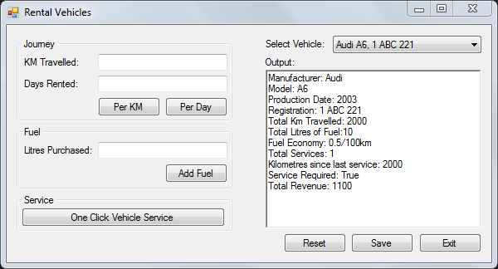

Program working below:

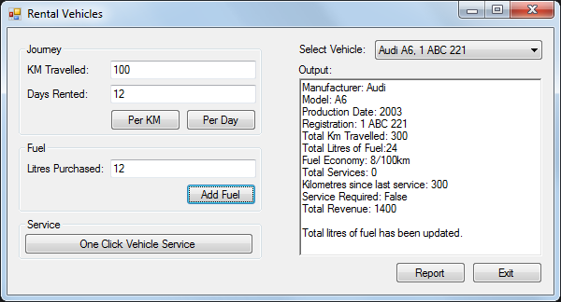

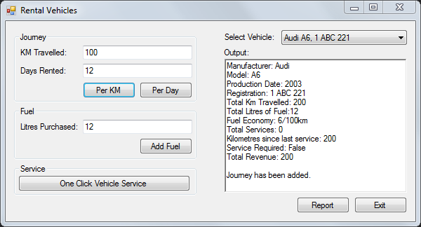

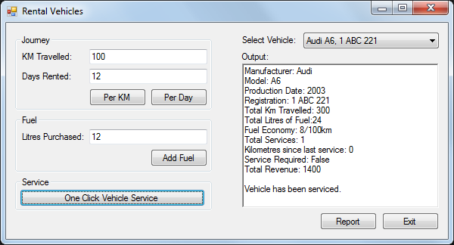

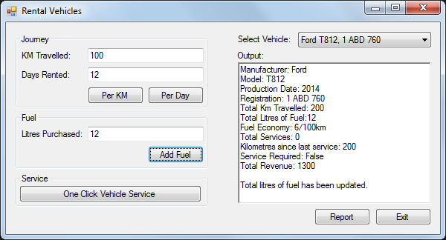

# Test Table:

Testing was done be Nick

|  |  |  |  |
| --- | --- | --- | --- |
| *Test ID* | *Description* | *Instructions* | *Pass/Fail* |
| 1 | On the main screen of the application, when a letter is entered in any of the textboxes, an error should appear. | On the main screen, enter “a” in any textbox. | Pass |
| 2 | On the main screen, when entering an invalid number in the “Days Rented”, an error should appear. | On the main screen, enter “-1” in the “Days Rented” textbox. | Fail |
| 3 | On the main screen, when entering an invalid number in the “Days Rented”, an error should appear. | On the main screen, enter “-1” in the “Days Rented” textbox. | Pass |

# Unit Testing:

Screenshot Evidence below

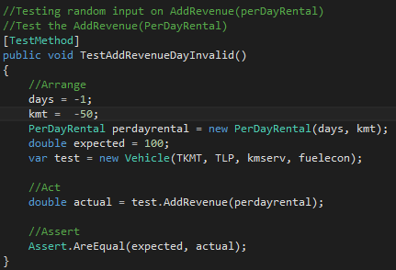

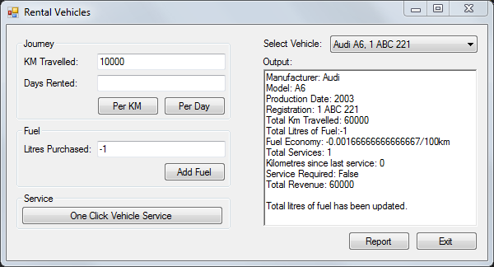

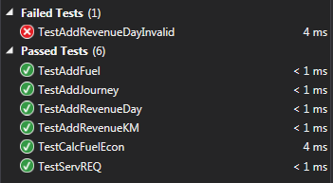

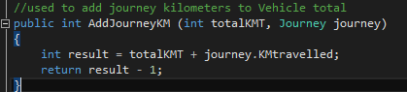

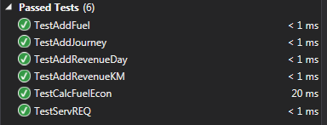

# GitHub Link:

<https://github.com/JacobCerff>

# Knowledge Evidence:

1. Hardware

|  |  |  |
| --- | --- | --- |
| Features/Capabilities | Brother DCP-J125 | Canon Pixma MP970 |
| Printer type | Multi-function | Multi-function |
| Ink type | Dye-focused | Pigment + dye-focused |
| Feeder capacity | 100 | 150 |
| Max optical resolution | 1200 x 2400 dpi | 2400 x 4800 dpi |
| Direct printing | No | Yes |
| Wi-fi | No | No |
| Bluetooth | No | Yes |

Software (OS)

|  |  |  |
| --- | --- | --- |
| Features/Capabilities | Windows 10 | macOS |
| Cost? | $79 | $129 |
| Customizable? | Yes | No |
| App store? | Yes | Yes |
| Maps? | Yes | Yes |
| Voice commands? | Yes | Yes |

1. Communication/Clarification

Having A complete and Clear understanding and answers that are easy to get across.

Customer satisfaction

Were you able to get the answers to the customer quickly and easily to the customer and was the customer satisfied and understood what was done.

Documentation

Reporting and documenting everything that was found and the process that it took to get an answer or not get an answer. This reporting is not only through a document but could also be a recording of the interaction

Identification/Analysis

Was the Issue identified and was it analysed for documenting purposes, also was the issue solved

1. Data Collection
   * Focus on facts
   * Display data in a manner that is easy to read
   * Include the cycle time
2. Process

Have a quality process implemented to ensure a smooth development period.

Commitment

Ensure that the developers are committed to providing the best possible product/service to the customers.

Testing

Ensure that testing is conducted at every major step to quickly fix any issues that may arise.

Deliverables

Define goods and services that should be delivered (e.g. test plan, requirements).

Maintenance

Even after the release of a service or product, ensure that the product/service is consistently updated and fixed.